9.66: a) By successively integrating Equations (9.5) and (9.3),
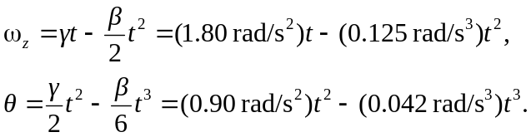
b) The maximum positive angular velocity occurs when 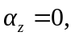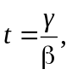 the angular
velocity at this time is
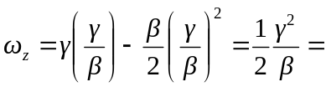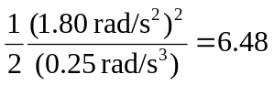 rad/s.
The maximum angular displacement occurs when 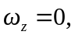 at time 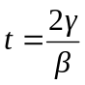 (t = 0 is an
inflection point, and 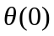is not a maximum) and the angular displacement at this time is

